Django structure

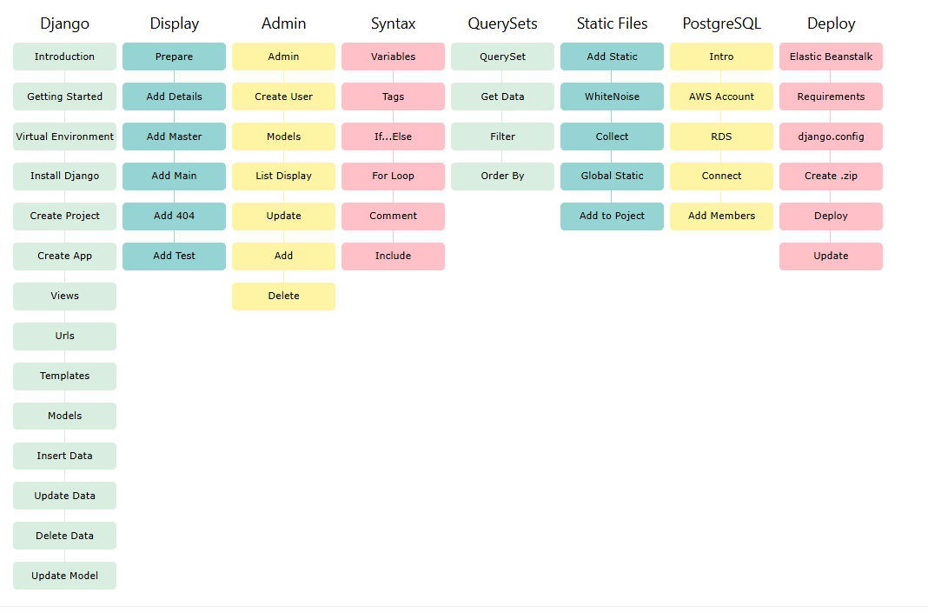

**1)Creating Apps in Django**

App create krny k bad setting may ja kr external_app = { apps name} phr next line installed_apps += external apps

**2)Explaining Views And URLs in Django Detailed Tutorial**

Django server data return krny ga backend sy

a)logical part view k andr likhty h pr urls.py k andr routing ka kam krty h

2 type k view hoty h c class base or function base

Apna ek function banaya phr usko http sy return krwaya

Def home(request)

Return HttpResponse(“Hello Cloudchain technologies)jb b humra serve chly to route py ja kr yeh msg show ho us k lie humy bind krna hota

Is k lie urls.y may ja kr .upper file ko import krna h is k bad patterns may path (‘’,home ,name =’home’) first path second function name hota h /

Html ka template return krwany k lie humy is k lie hum home(apni app) may ek templates name ka folder create krty h is may ab ek web.html file rkhni h . or route py ja kr reload krny sy wo show ho jaye gi.

Is k lie http response ko hta dety h or render method ko use krty h

Def home(request)

Return render(request , ‘web.html’ )

Ab apko templates k andr apni app name ka folder banana h phr us may apni html file move krni h or view may ja kr file sy pehly app ka name dena h Return render(request , ‘home/web.html’ )

**3)Template Engine**

Data server sy atta h html form sy ni.mtlb views.py sy data pass kr k html may show krwana h

Views.py sy data context sy html tk ly k jaty h. people=[{‘name’:’Ahmad’},{‘name’:’Arsalan’}]

Return render(request , ‘home/web.html’ , context={‘people’:people}) ab html may ja kr {{people}}

Is may forloop or if else statement lgaty h assy

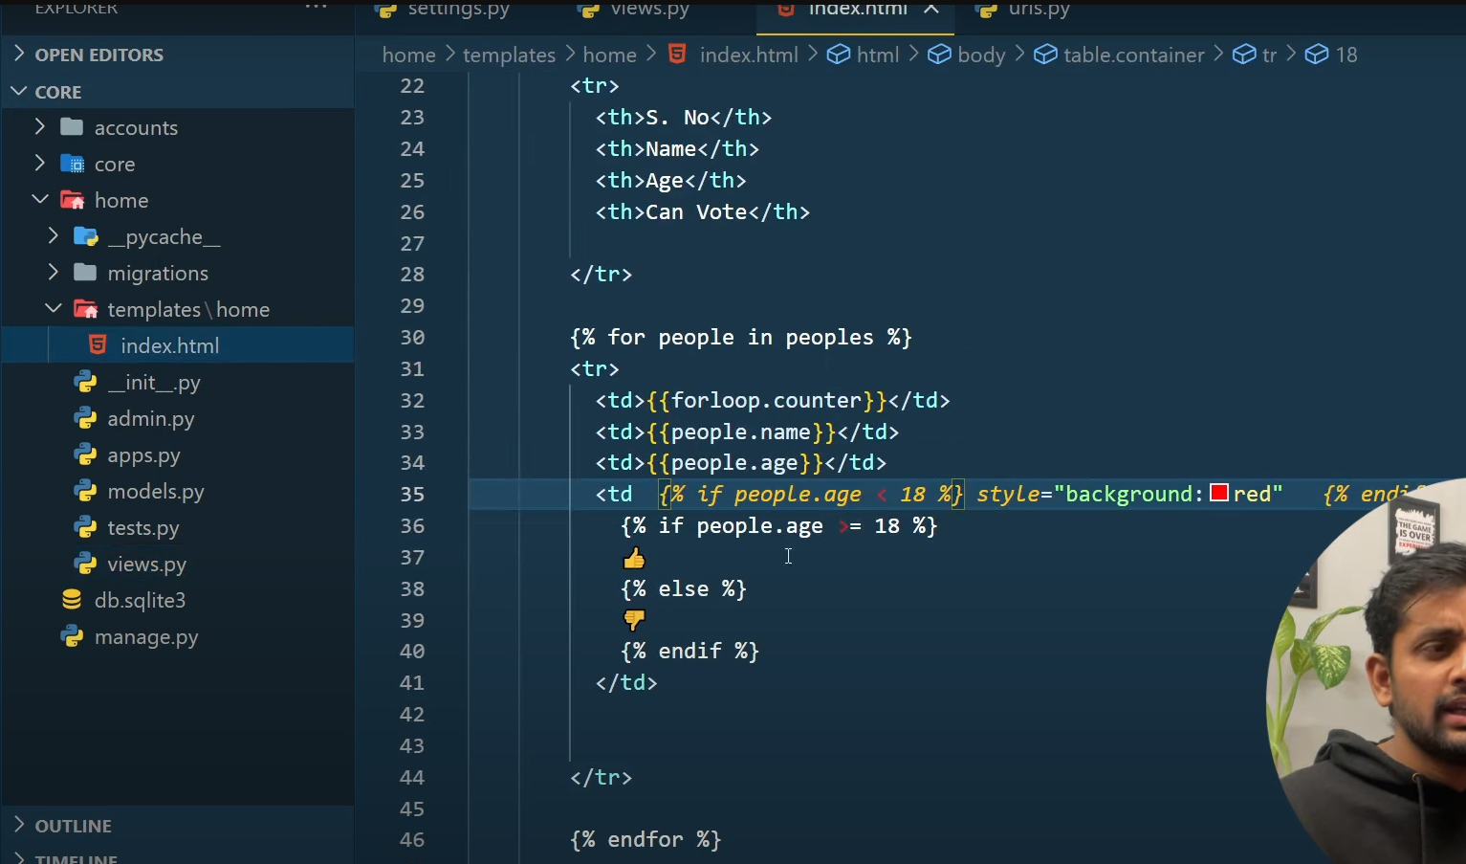

Yeh data humny manually add kia tha . character limit may dikhany k lie {{text|truncatechars:10}} use krty h

If condtion using in index.html yeh data leta h views.py sy

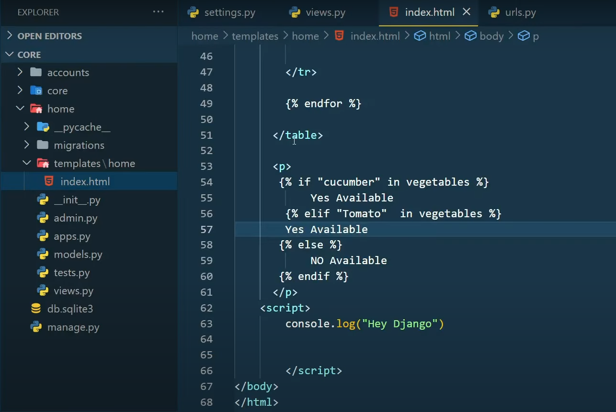

Ek or contact.html bnai humny

3 html documents bnaye h ab view may ja kr 3 function create kr k unko render krty h

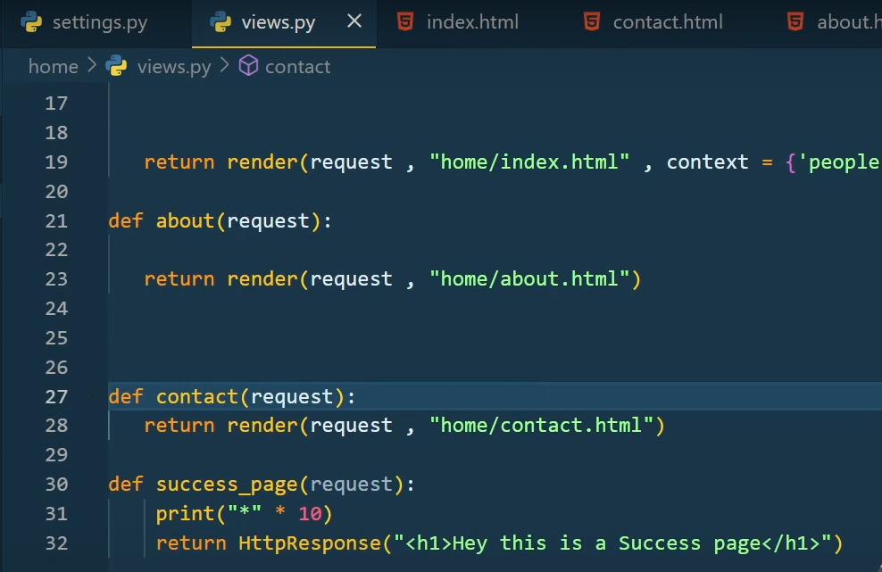

Ab humy urls.py may ja kr inka route define krna h .assy

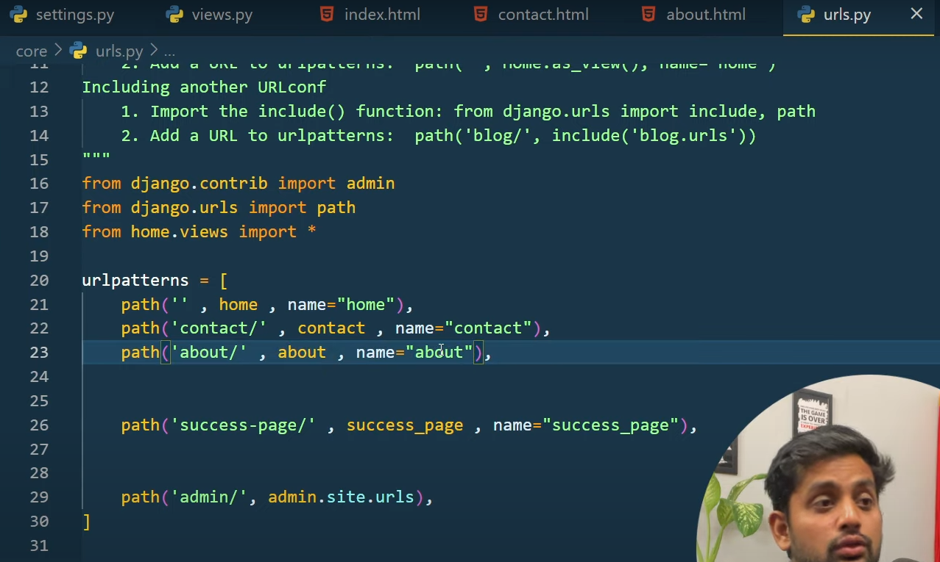

Ab hum inki url set krni h. <a href =”/”>Ho,e <a/> yeh static url h .

Ab hum similar code ko remove kry gy Django template engine sy.usy home waly folder may ja kr hum ek base.html ki file bnaye gy.sub common code ko paste krna h is base.html may.isi file may body k andr {% block start%} {%endblock%} phr jis file may wo code lana h us may ja kr start py {% block start%} end py {%endblock%}.ab start may inhertence ka reference dena h assy{%extends “base.html”%}.jo b data hum base html ki body may likhy gy wo common ni rhy gi . issue sub py heading same a rhi h usko dynamic krny k lie humy views.py may ja kr function may ja kr context add krna h assy

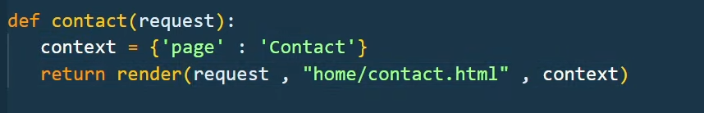

Jonsy page py b change krna h unka function assy adjust kr dena h .bs page k aghy wala name change krna h jaisy contact h about waly may about krna h .

**4)Models and Migrations in Django**

Model.py may sub krty h kam or is my hum database ka schema dikhany waly h. hum classes k sath is may kam krty h. class Student(models.Model): is sy model bnata h .

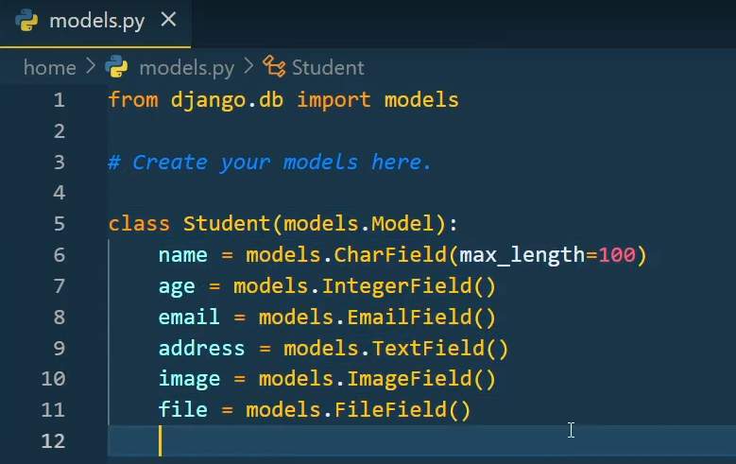

Yeh model structure h .auto field b hoti h .like id = models.AutoDield() yeh primary hoti h.jb b ap model may change krty ya koi new model bnaya to migration ki command run krna prti h .migration run krny k bad model k andr ek 0001_intial.py ki trah file bn jati h. is file may dependencies or opertions boht imp hoty h.

Imp agr ap first migration file delete krdo alteration k bad to db may Django ko pta chl jata h.

Djnago sub internally migrations command ko run krta h.phr model ki ek state bnata h phr dono ko compare krta h.

**5)All About Django Shell Most Important Django Topic**

This is a kind of bridge and a shell jis may ap kafi cheezy kr skty ho.humy kuch b add krna hota h hum views may ja kr add krty h.

Model may koi b cheez add krny k bad migrations then migrate ki command run krni h

Django k database sy attract krny k lie hum sub kuch Django k shell may likhty h .

Command = python manage.py shell

Model k andr waly database may table may change kry gy shell ki help sy .pehly model ko import krna pry ga. Command = from home.models import * ab hum student class may data daly gy assy 1)Command = student = Student(name =”ayandar”,age=26,email=”ayandar165@cloudchain.com”,address=”FSD”)

Ab humy is data ko save krna h . Command= student.save()

Ek 2)dosra way b hota h = student= Student.objects.create()->object is a model manager

student = Student.objects.create(name =”ayandar”,age=26,email=”ayandar165@cloudchain.com”,address=”FSD”)

db may records save h unko get krna hota h = Students.objects.all()

ab kisi object ka data get krna ho to = Student.objects.all()[0].name->0 is first index->.name is is index may name ko show krwao or b kych show krna ho to . k bad uska name likh do

ab shell k andr function bna k usko test krna h pehly hum ek file bnaty h template dir may utils.py is may model import kr k database table import krty h us k bad function bnaye gy.

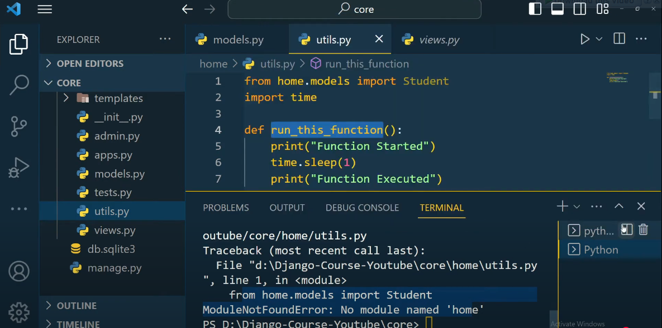

Yeh run ni hoga error through kry ga is k lie humy django shell use krna prta h.

Django shell run kr k .impotrt kia command= from home.utils import*.ab run_this_function() hit enter.django shell sy ap database may sy data b dell kr skty h.agr humy table may id ko check krna h to . Students.objects.all() kr k sub student k objects a jaye gy .phr Student.objects.all()[0].id

**6)Complete Advanced CRUD operation in Django**

Crud = create, read, update, delete

Ab hum model.py may ek model bnaty h kind of Car

Class Car(models.Model):

car_name = models.Charfield(max_length=500)

car_speed=models.IntegerField(default=50)

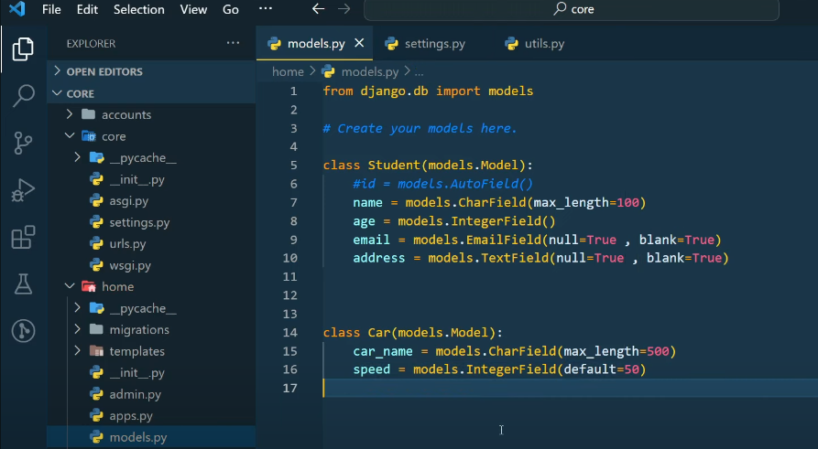

Is k bad hum migration hit kry gy = python manage.py makemigrations.is k bad = python manage.py migrate. An shell k andr jaye gy python mange.py shell . is k bad from home.models import *. Is k bad car = Car(). car = Car(car_name=”Nexon”.speed=110). car.save()hit enter

Ab ek or car object create kry gy .object method jb hum use krty h to hum car.save() ni run krna prta.ab shell may ek dict bnaty h .3)car_dict={“car_name”:”Alto”,”speed”:80} enter is k bad car.objects.create(**car_dict)

Nechy image may 3 way shell k sath run howy h

3 waly may hum Jason format wala data b pass kr skty h .

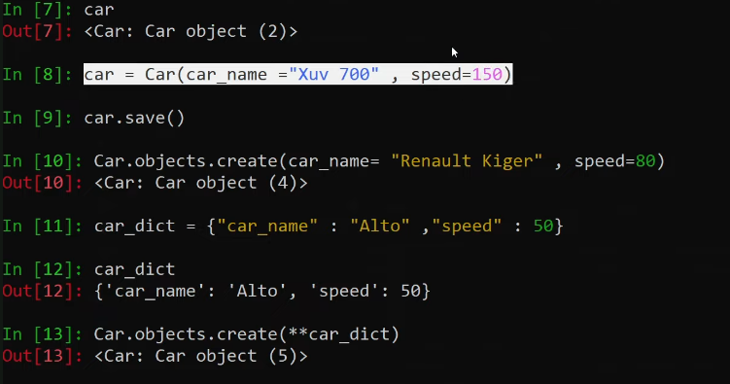

CRUD may C= create wala portion ho gya h humra.R=read cars = Car.objects.all() is k bad car enter read wala b hi gya h ab hum objects k jgha car ka name b print krwa skty h us k lie humy models.py may ek function bnana pry ga .

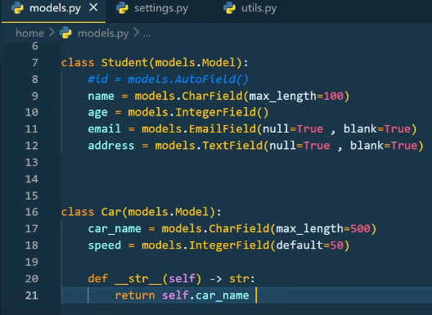

From home.models Import *

Cars = Car.Objects.all()

Cars

Ab hum using for loop sub ko b print krwa skty h assy for car in cars:

Print(f”(car.id) The car name is {car.car_name} with high speed of {car.speed}”)

Agr specific id ko read krna ho to car =Car.objects.get(id =1) agr wo id present na ho database may to get method ek exception error return krta h .kafi method hoty h like get ,filter ,update,delete etc.agr apko idea na ho k kitni id present h to error sy bchny k lie ap get ki jagha filter use kr skty h yeh error ni through kry ga .U pehly car object lely id k name sy assy

car =Car.objects.get(id =1)

car.car_name=”Civic”

car.car_speed = 180

car.save() is k ilwa hum update method ko b use kr skty h assy

car.objects.filter(id=1).update(car_name =”Honda Civic”)

D Car.objects.all().delete -> is sy sarry record delete ho jaye gy .koi specific delete krny k lie Car.objects.get(id =1).delete() yeh idwise record delete krdy ga.

7)**Create a RecipeProject in Django - Part 1**

Create app = python manage.py startapp food

Is may hum model bnaye gy mode.py may or model classes ki help sy bnty h.

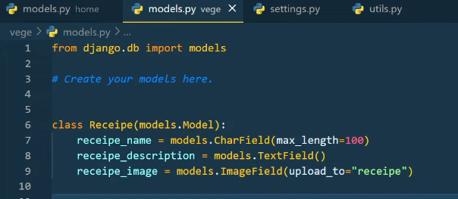

Ab setting.py may is app ko dalna pry ga.external app waha hum ‘food’ dsal dy gy.

Ab isko migrate krty h = python mange.py makemigartions

Python manage.py migrate ab databse may ek table registered ho jaye gi.ab hum server run krty h python manage.py runserver. Ab humy ek template return krna pry gi us k lie hum views.py may jaty h or waha import k bad ek function bnaty h.

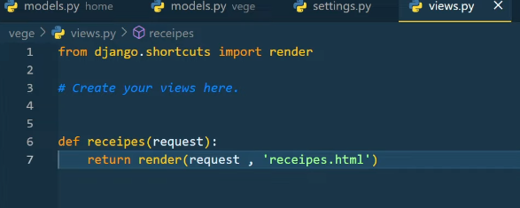

Is k bad app may hum ek folder bnaye gy template name ka us may receipes.html file ko bnaye gy.waha code add kry gy us ka bad urls.py may ja kr hum route define kry gy pehly hum view Import kry gy food ka

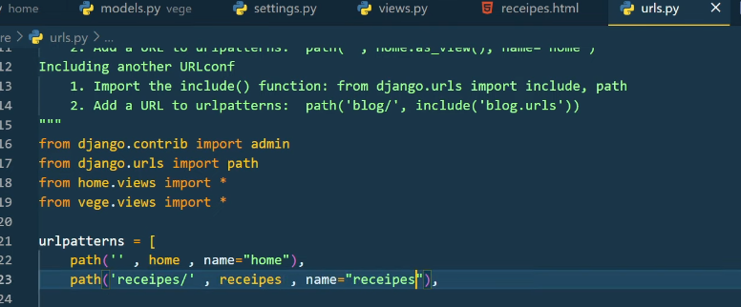

.html file may hum boostrap ki website sy ja kr form ka code copy paste kry gy or template ki help sy base html ko import krty gy 2 line of code sy

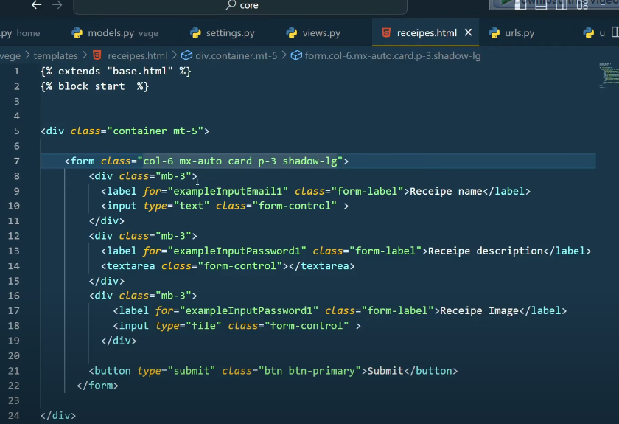

Ab hum jaisy hi add py click krty h to humra data jo h wo humary model may save hon chahie.

Measns frontend sy data backend may kaisy ly kr jaty h easy way may jo data user add kry ga usko view.py tk ly k jana h jo user ko show hoga.is k lie kisi b framework k ander name variable add krna prta h.phr form may method add kry gy post yeh DB may data bejhny k lie use hota h.

Frontend sy data backend may method k zariye data send ktry h.or backend sy frontend may data context k zariye bejha jata h

Nechy wali pic may implement ka best way h

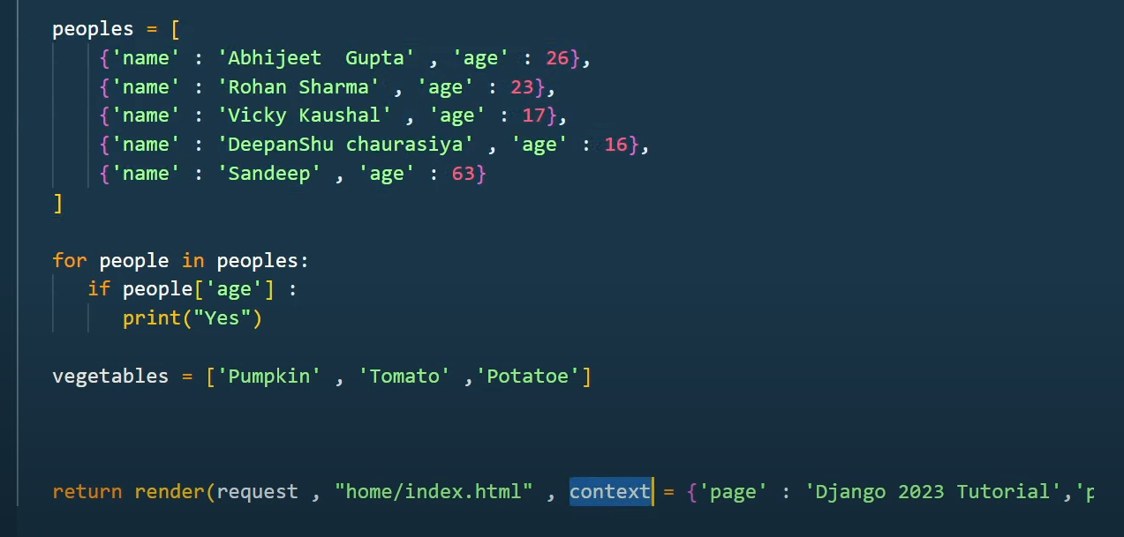

Ab humy name both fileds may add krna pry ga jo humny model may dya tha wohi html may pass krna pry ga or form k andr enctypr”multipart/form-data”

Humari final .html file ab assy hogi

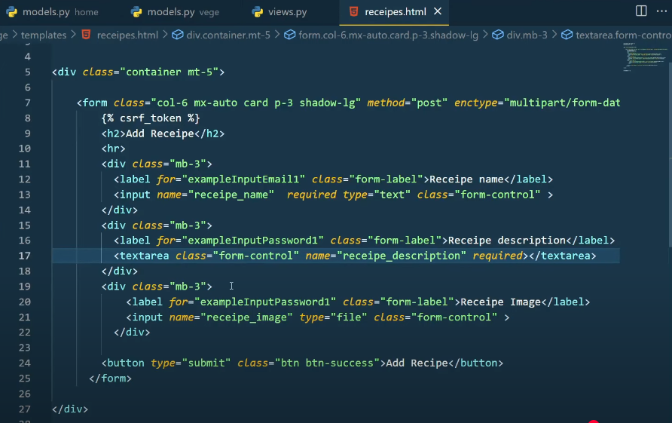

Ab yeh sub data ko view may lany k lie humy data = request.POST is k bad data ko show save krwany k lie ek token b use hota h {%csrf_token %}.crsf token conform krta h jo b cheez add up ho rhi h wo same machine sy hi ho rhi h agr yeh match na ho to wo error through krta h .

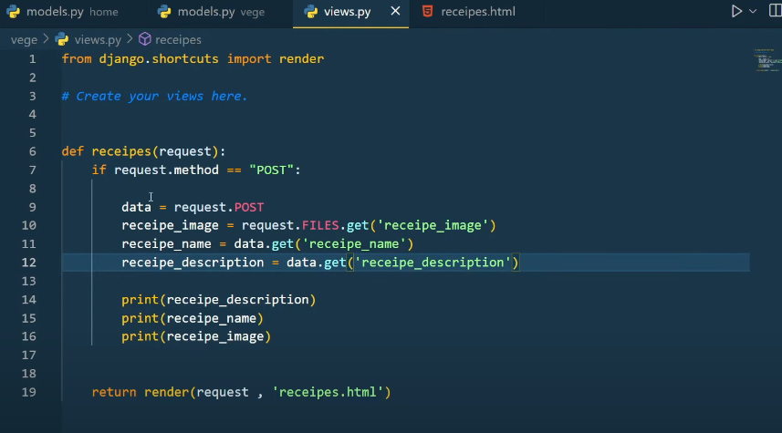

Ab hum view py jo code likh rhy h yeh humy terminal may output dikhaye ga .yeh upper wala data save kr rha tha but yeh local machienya database may ni tha yeh just output dikha rha tha terminal py

ab humy model may data ko save krna pry ga.

Pehly model ko import krna pry ga view may us k bad function bnana pry ga same assy

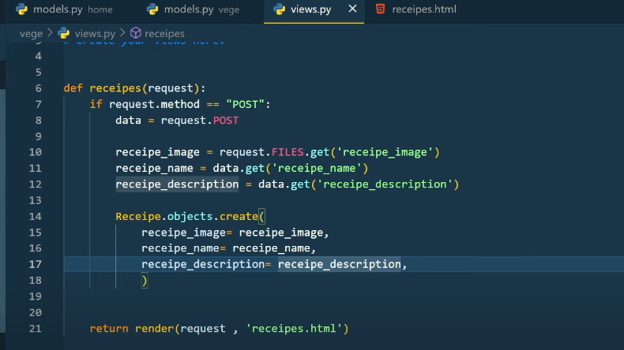

Save krny k bad recipe folder bn gya hoga or us may image show ho rhi hogi.

Ab hum isko dikhan h apny frontend may to is model ko register krna pry ga.wo admin.py may ja kr

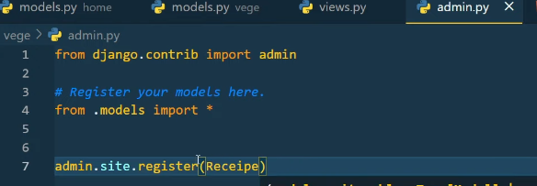

Ab isko shell sy check krty h k DB may data save howa h y ani

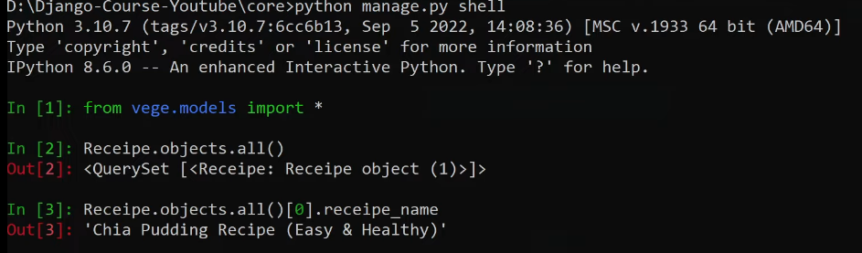

Humra code redirect ni h is k lie humy isko redirect krna prta h views .py may

Pehly import kro redirect us k bad last may return redirect(‘/receipes/’)

8) **Create a RecipeProject in Django - Part 2 | Writing Whole Recipe Logic**

Backend may jo data create Kia h usko front end py show krwaye gy view ki help sy.

Apni application k view may jaye gy. Ab hum contxt may recipe ko bejhny waly h.

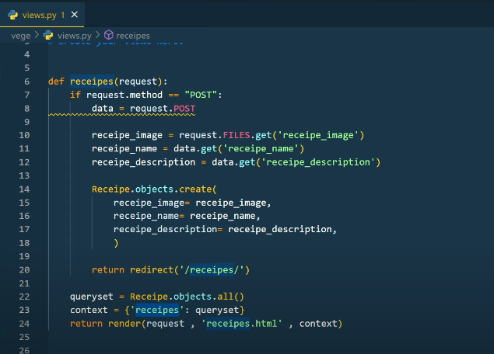

Ab is recipe ki value ko apny html templates may ly kr jaye gy.recipe.html may form k nechy {{recipes}} Is sy data dict form may ui py show ho jaye ga .ab ui ko table form may data show krny k lie hm html may ek table bnaye gy getboostrap ki web s table ka code copy kr k {{recipes}} k nechy code paste kry gy. Phr table may hum data show krny k lie forloop use kry gy{%for recipe in recipes%} and last py {%endfor recipe in recipes%}phr {th} may {forloop.counter} use kry gyzero index sy aghy tk loop chalny k lie

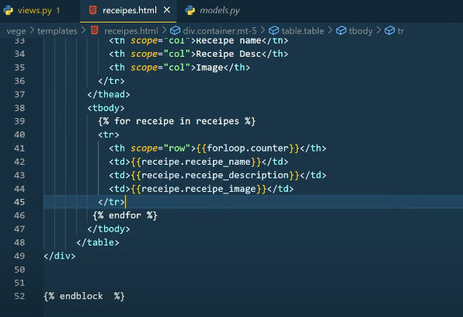

Image show krny k lie ui py dajngo ki mtter dir ko set krna prta h . is k lie seeting.py may jaty h

Ismay static_root Django k admin panel k lie hota h or static_url normal java or css k lie use hota h.media_root media files k lie use hota h

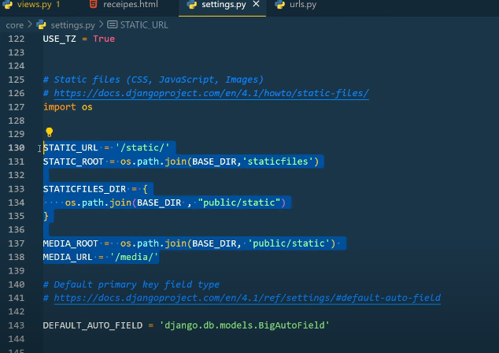

Ab isko ui may show krwany k lie url.py may ek lib import krty h.from Django.contrib.staticfiles.urls import staticfiles_ulpatterns ab hum image upload kry gy to humari app k andr k public folder bna us may static phr humari file usmay ja k save hoi .

Actual may hum koi app bnae to pics data cdn (content dilvery network aws) py k through upload krty h

Ab html form may image ko display krwna h .

<img src=/media{{recipe.recipe_image}}” style=”height :200px>

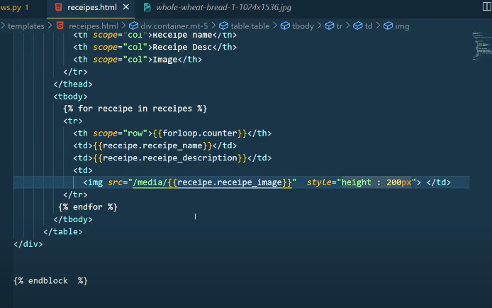

Ab recipe ko delete krna h to <th> may action ka tage dy kr imgae k nechy <td> <button class=”btn btn-danger “>Delete</button></td> is k bad hum is curd ko ui py perform krny k lie ek view may new route bnaye gy

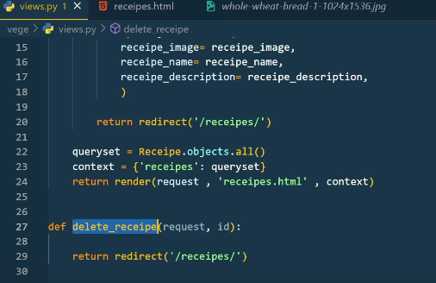

Ab is route ko register krty h urls.py may urlpatterns may path(‘delete-recipe/<id>/’,delete recipe name=delete-recipe)

Views may assy delete function may http response pass kya

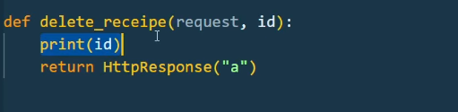

Ab hum is function ko update krty h views.py may.

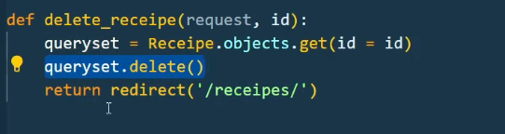

Ab urls ko set krty h us k lie recipe.html nay ja kr href may funxtrion name views ka

<a href=’/delete-receipe/{{receipe.id}}’

**9)Create a Recipe Project in Django - Part 3 | Writing Whole Recipe Logic**

Urls.py may ja kr path dia update-recipe ka path=(‘update-recipe/<id>/’,upadye-reciepe, name =update_recipe) ab humy iska route likhna pry ga views.py may function k through phr usko setting.py may ja kr set krna pry ga

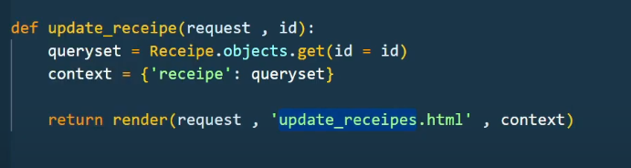

Ab update recipe ka ek template bnaye gy phr recipe.html may ek button dena pry ga update ka

Update_reciepe.html kuch asa hoga

Mb-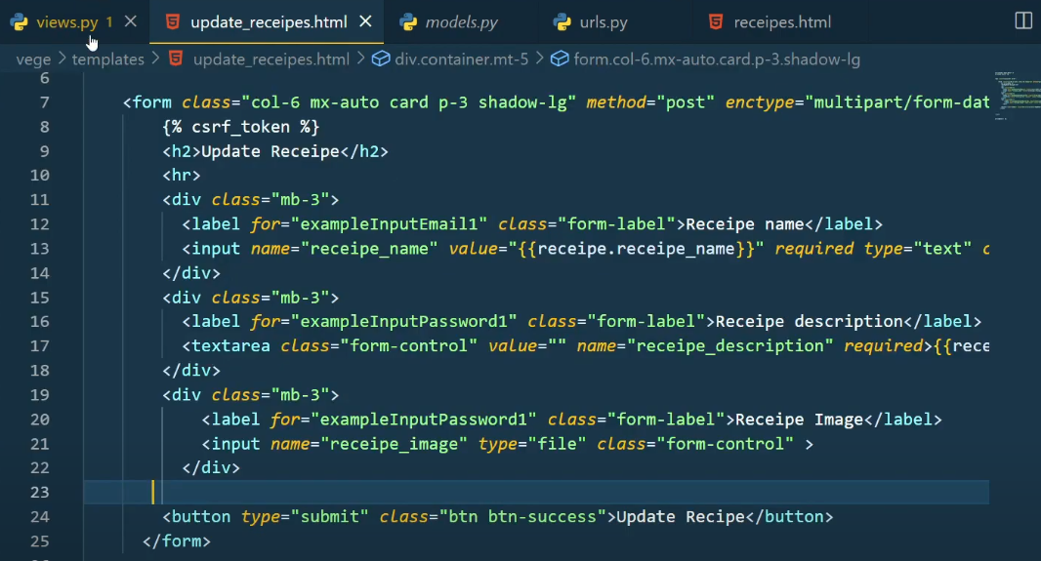

Mb-3 may humny value ={{}}pass ki ha baki same code h .

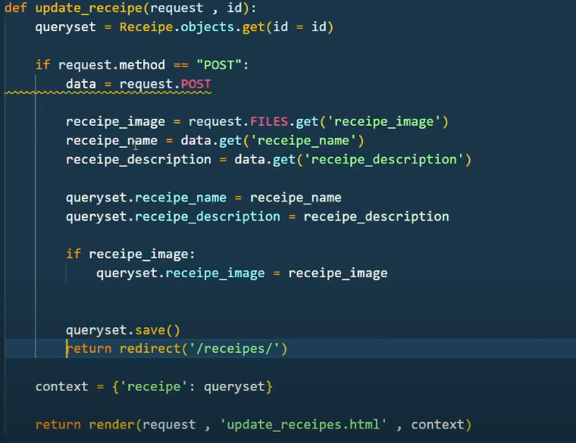

Ab hum serach functionality add kty h apny program may .recepie.html may form k upper

<div>add kry gy

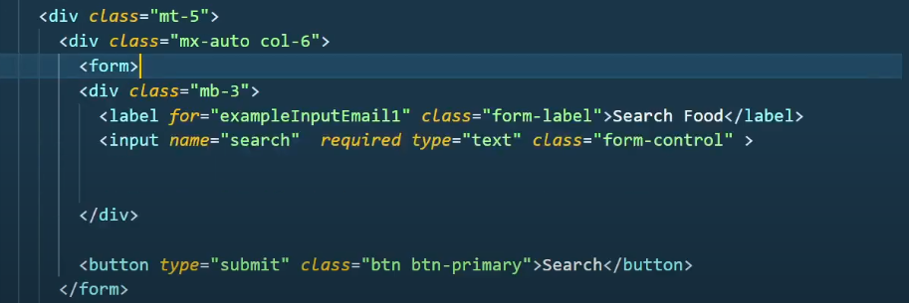

Ab key ko backend may pass krni krti h .is k 2 type hoti pehla data= request.Post or dosra if request.GET.get(‘’search” ):

Queryset=queryset.filter(receioe_name_icontains=request.GET.get(‘search’)).

Views.py may yeh if condition add krni h.

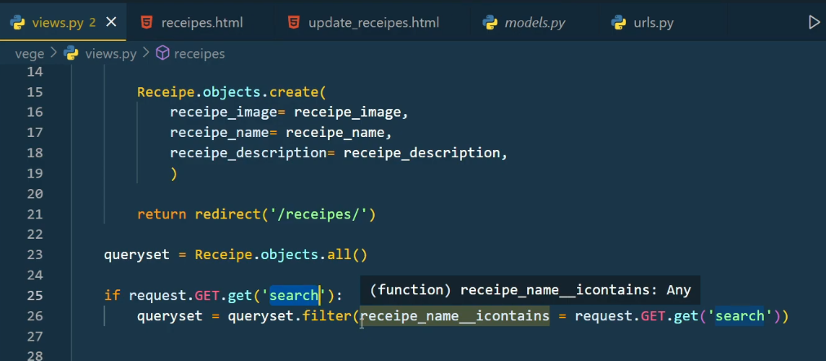

**10) Advanced Authentication in Django | Django complete tutorial**

Django is battery including framwork, models.py may ja kr hum pehly user model ko import kry gy

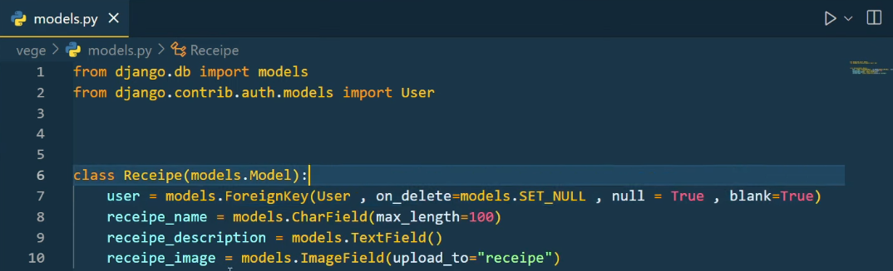

Ab is ko migrate kry gy hum.python manage.py make makemigrations phr python.py migrate.

An hum templates may ek login page. Register page ready kr lety h .boostrape ki website sy ja kr ek form ka code copy kr k login.html may paste krna h . is k bad ek view create krly gy hum .

View.py may ja kr function ki help sy .is k bad core k urls.py may ja kr path dena h or isko register krna h

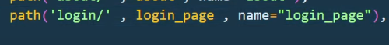

Is trah hi register wala page b yaha add krna h . us kl bad views.puy may ja kr uska function bna kr k usko add krna h .

Ab hum register.hml waly page may ja kr name add krty h ab hum view.py may ja kr yeh function add krty h

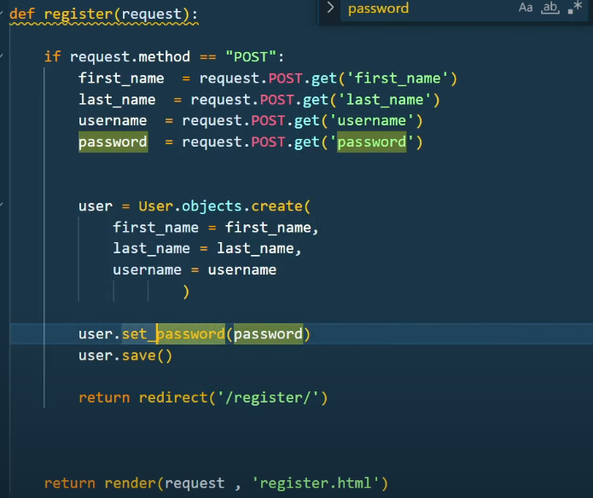

Ab hum user model ko import krnsa pry ga.ab hum isko return redirect krdy gy register.html py assy humea ek user create ho jaye ga .jb hum ek user register krdy gy or backup may usko kaisy daikhy gy. Python mange.py shell . from django.contrib.auth.models import *

User.object.all(). User name same ni hota agr koi wohi user rkhy ga to error aye ga unique consest ka is ko solve krny k lie register waly function may ek user = user.obkects.filter(username=username)or if statement daly gy is trah if user.exists():

Return redirect(‘/register/’) ab error msg b dalna chahie k yeh uer already h to app yeh ni user name likh skty .

Is k lie pehly ek class import krni prti h.is k sath humy boostrap b add krni pry gi html file may

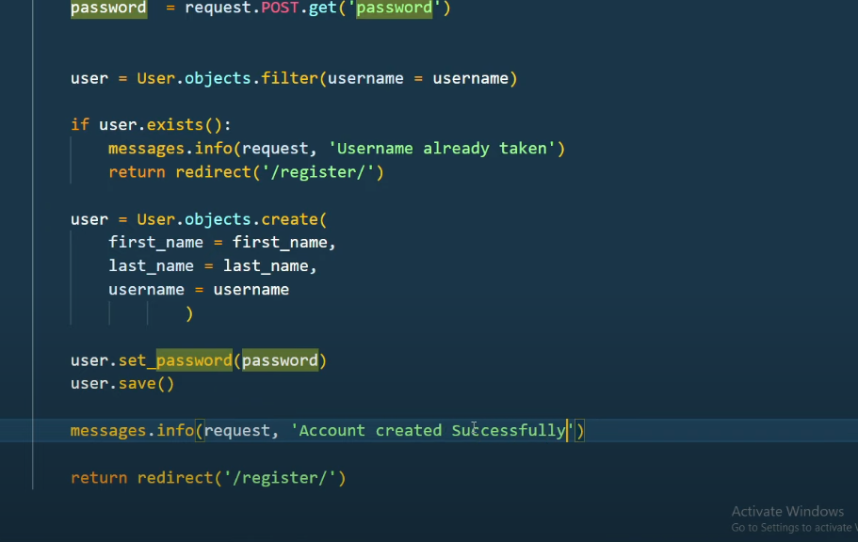

Register.html may ja kr form k nechy boostrpe ka code paste krna h

**12. Master Django ORM | Learn Core Concepts about Django ORM which no one tells**

Model may jo b change krty h us k bad migrate krty h.

Open python shell and save recipe object in ascending order

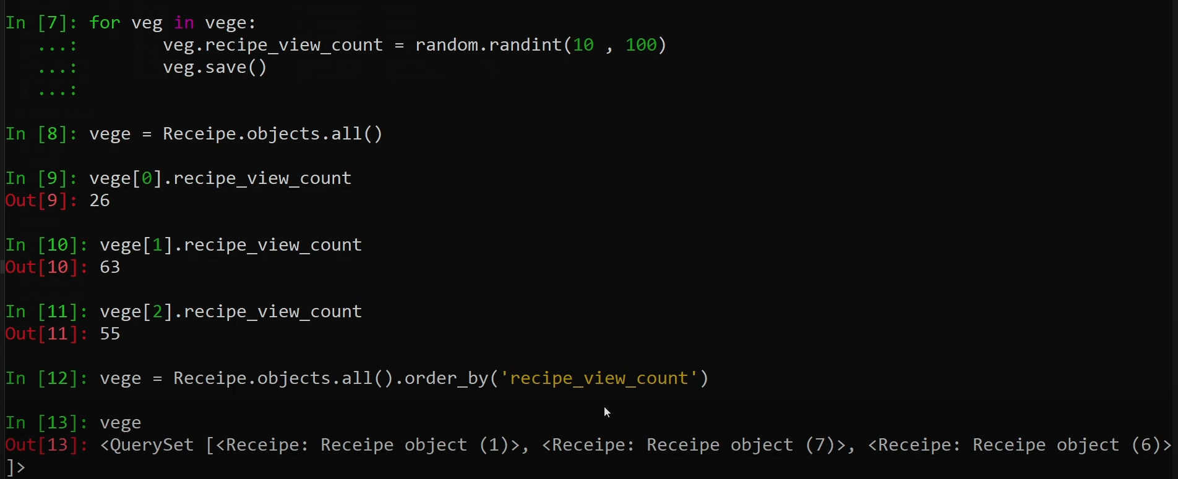

Agr humary pass lac of recored ho to humari query crash ho jaye gi .us cause k lie humy limit lgani hoti h . limit assy pass krty h

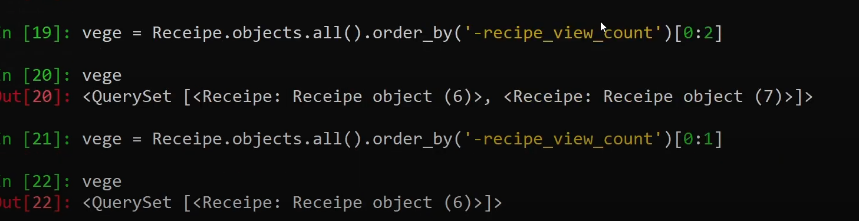

Make a limit most viewd objects in my application of receipe. Is k lie huy filter krna prta h.

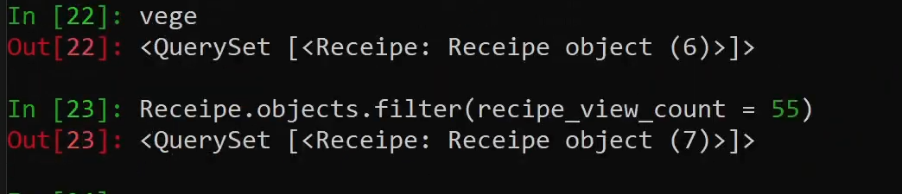

Ab hum __gte special string lgaye gy.gte ka mtlb greater then hota h

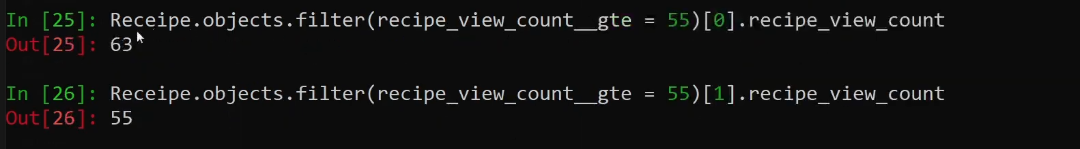

Lessthen k lie hum __lte use ktry h.

**13. Master Django ORM | Learn Core Concepts about Django ORM which no one tells**

4 models bnaye humny. Phr unko migrate kia

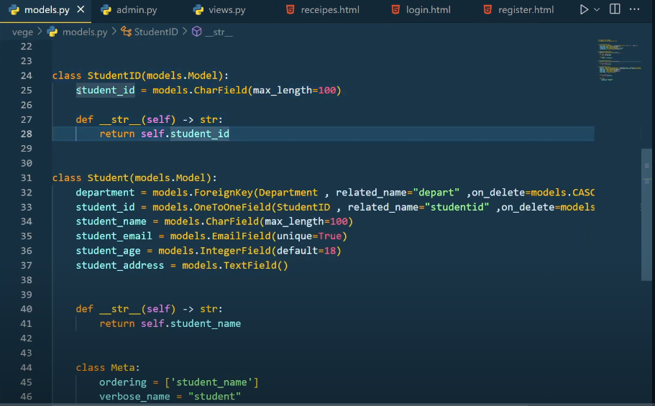

Ek std key k andr boht zyada value ho skti h us k lie humny foreignkey lgai h jis ka mtlb one yo many hota h . like ek department may kafi zyada std ho skty h

Ab hum admin panel bnaye gy or isko use kry gy.iski

command = python manage.py createsuperuser is k bad user name pass krna h.phr email dy gy

phr password dy gy.yehi model hum admin.py may register kry gy

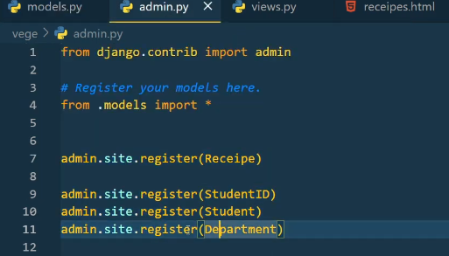

Ab hum fake data generate kry gy apna time save krny k lie .faker lib ki help sy

Ab hum seed.py may faker ko Import krty h or dump data add kry gy

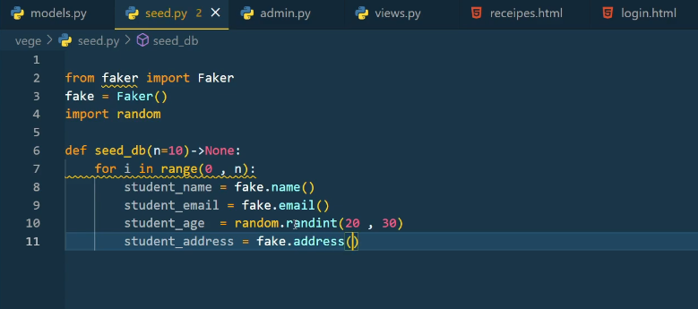  
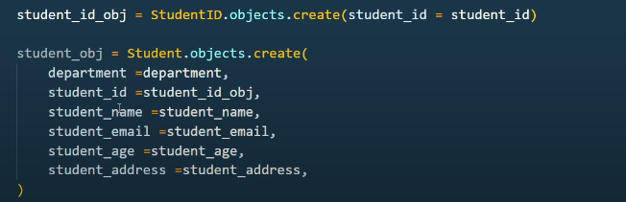

Ab hum try expect use kry gy is k bad hum apny server ko run kry gy. Or phr python shell open krly gy/phr

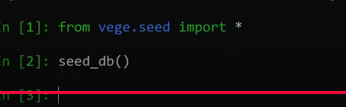

Check krny k lie again server ko run krly jitni dfa hum function ko call kry gy utni dfa 10 std add hoty jaye gy ku k humny range 0 -10 di hoi h .is k bad hum Django ki query perform kry gy

Yeh kam hum app may managments/commands/.py bna kr is .py file may code likh kr python python manage.py runscript your_script.py

**15. Advanced Queries About Django | Learn Core Concepts about Django ORM which no one tells**

Python manage.py shell k bad yeh commad run krni h yeh data model may sy show krwata h

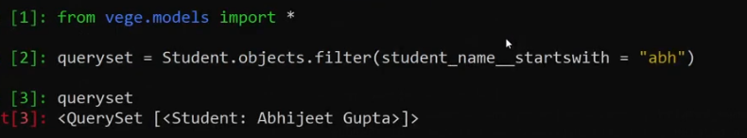

Objects.filter that filter the values in sets form

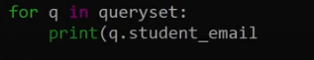

This show the all emails in student column.

Also we filter the data with ends with



It show the data with name (__icontains=’’)it show the data that table contianed

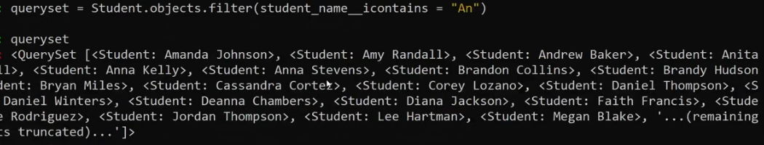

Ab mjhy student ka department check krna h. or department ek foreigenkey h usko access krny k lie .humy pta h queryset may ek list a rhi h . or list ko access krny k lie [0] lgaye gy index k lie

Hum queryset[0].id or queryset[0].pk hr django server may hoti h yeh primary key h . primary key django automatic add kr k deta h o sy start kr k. student id or department hum assy nikatlty h

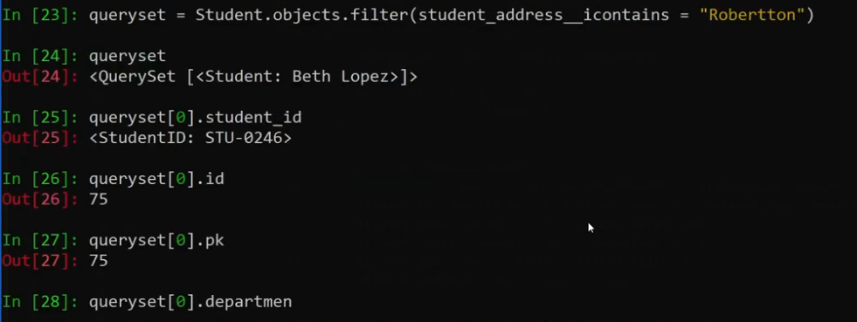

Agr queryset[0].department krty h to yeh Django k model may sy class may sy data ly leta h .

1)ab mjhy assy std ka data chahie jinka department civil ho .[0] iski index ko access krna chahty ko ap or __ ka mtlb hai yeh special cause h like ,startwith,endswith,icontains or ___ djngo may forgien key k lie hota h. depending on your need kbi forgien-key k lie use hota kbi djnago k function k lie

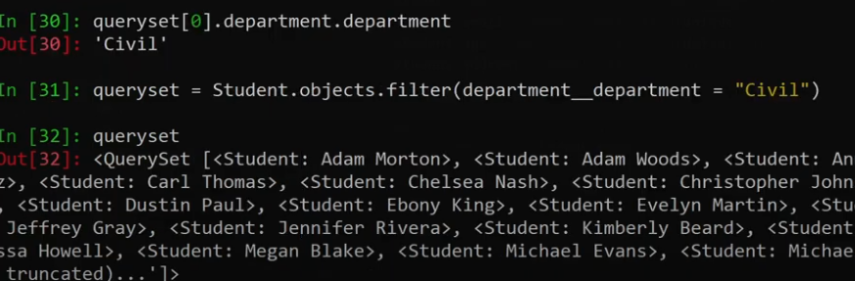

2 dfa department is lie use howa first us class may jana 2 uski value leny k lie.

Ab hum departrmant k bad hum Icontain use kry gy computer or civile l std check krny k lie

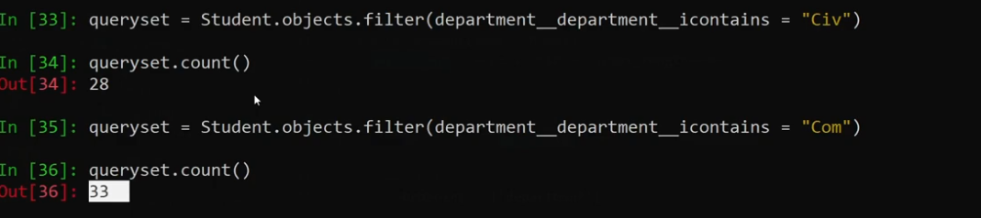

2)assy student ka data la klr do jinka department civil ya com ho

Pehly hum ek variable may list pass kry gy us k bad list dedy gy us may dono ko

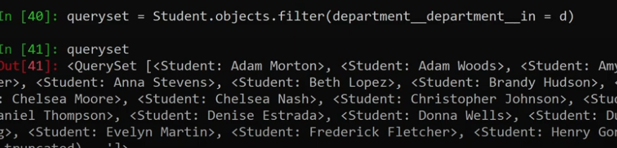

Agr hum queryset.count() yeh total num bta dy ga

3)sub department ka data chahie bs civil ka ni chahie

Filter k jga hum exclude keyword use kry gy hum

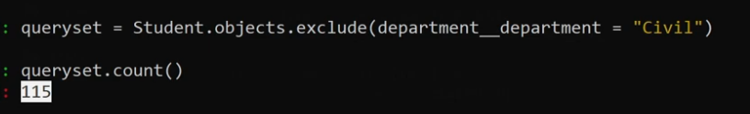

Hum exists use krty h true or false k lie mtlb data h to true ni h to false

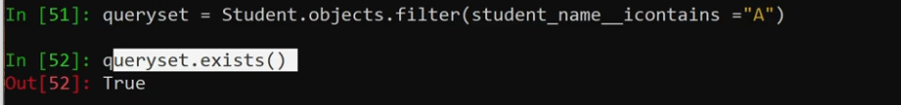

Filter krty howy all k jgha ap slicing b use kr skty jis sy apka ui ya api na phaty.queryset[0:100]

Queryset.values() yeh humy dict data h result may. Or Queryset.values() [0] yeh fisrt ka data dikahye gi.

Disnict key word sql lite support ni krta data ko reverse may lany k lie .reverse()use hota h .

Ab hum data ko list form may b filter kr skty hai .

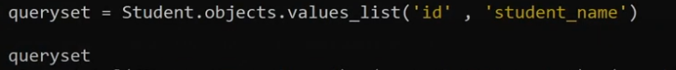

Get tb use krty h jb ap sure ho data any wala h wrna yeh use ni krna exsepetion any wali h .

For read Django query set = [QuerySet API reference | Django documentation | Django](https://docs.djangoproject.com/en/5.2/ref/models/querysets/)

**16. Aggregation and Annotation in Django | Advance Topic**

Aggregate function ek row py kam krta h or filter function ek column py kam krta h .

Aggregation may hum rk column may hum average total sum etc kr skty h ek row py

Annotation two or us sy zyada row py kam krty hai .mtlb 2 row ya table py jb hum koi function execute krty h to usko annotate kehty h . Annotation ki help sy hum 2 aggregate dunction ko use kr skty h .

For more information read out : [Django documentation | Django documentation | Django](https://docs.djangoproject.com/en/5.2/)

Finding a aggretaion on a age of student like hum find krny lgy hai average age

Is class ko import krna h from django.db.models import *

from vege.models import *

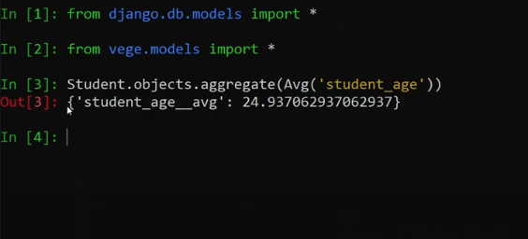

Assy average find krty h

Assy hi min,max,sum nikal skty h avg ki jgha key change kr deni h .

Ab hummy annotation find krni h like 20 and 24 age k kitny std hai etc

Ab hum 2 different column py average nikal skty h

Is may hum ek table py nikal lety h

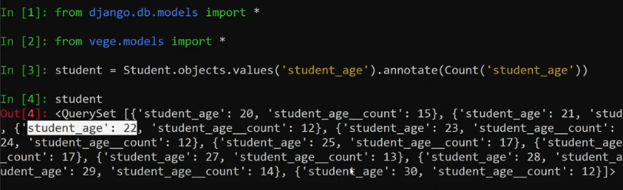

Std = student.objects.objects.values(‘strudents_age’).annotate(Count(‘students_age’))

Assy hi department or like sub tables ka nikal skty h



**17. Django Report card Project**

Creating a model means a class we create is k bad ek or class banani h subjects class k name sy

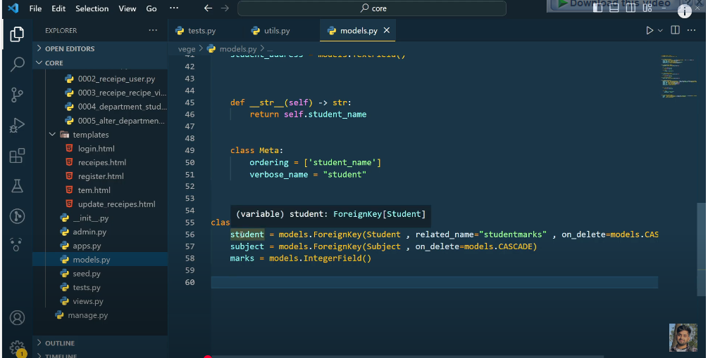Phr ek hi subject ka ek hi subject show krwany k lie humy ek meta class bnani prti h mtlb ek filed k andr std or subject repeat ni kr skty

Phr hum ek dender method call kry gy

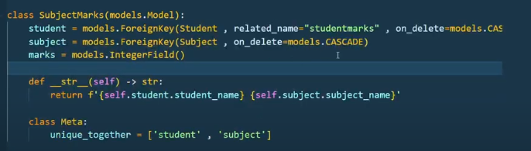

Is k bad migrations run krni h

Ab python manage.py createsuperuser

Is may hum department bnaye gy .phr hum is may hum subjects bnaye gy.

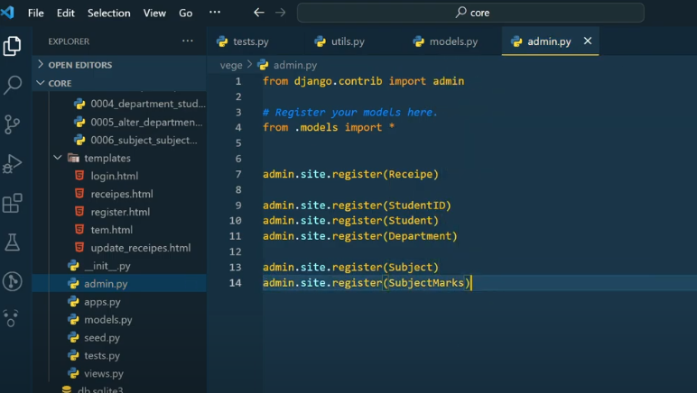

Models.py may ek class define krni h students ki   
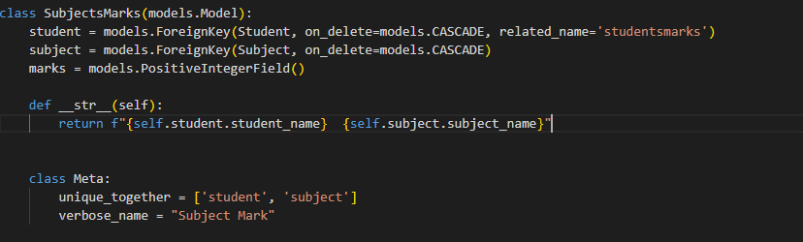

Ab humny data function add krna h seed.py may student marks k lie

Ab new student create krny k lie hum seed.py may ja kr class k through new std bnaye gy.phr hum Django shell ki help sy new students bnaye gy assy

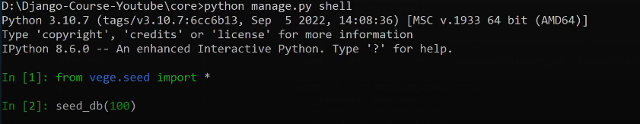

Is sy ek user register krwana pry ga is k bad admin.py may is models ko register krwana pry ga

Is sy 100 student create ho jaye gy ab humy student k marks b create krny h seed.py sy

Seed.py may ek function bnaty hai .function may pehly object ly kr any pry gy us k bad student ki length ko ly kr ana pry ga yeh student k random marks ko create krny k lie .is k bad loop k may hum student k marks random create kry gy .assy

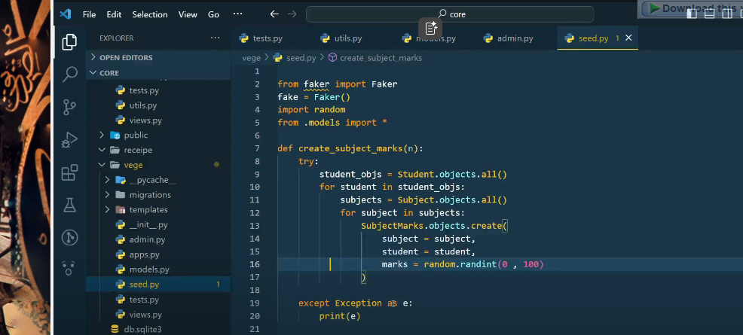

Ab marks again ja kr python shell sy bnaye gy function call kr k.check krny k lie server k admin pannel may ja kr check krly yaha sy : [Site administration | Django site admin](http://127.0.0.1:8000/admin/)

127.0.0.1:8000/admin/

Agr humy Django k admin pannel may hi spritely dikhna h to admin.py may ek class bna ly

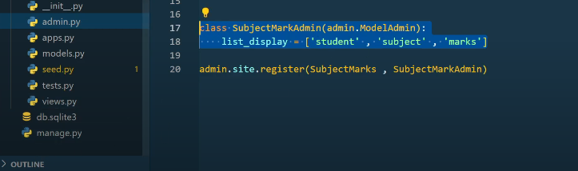

Is sy assy show hoga

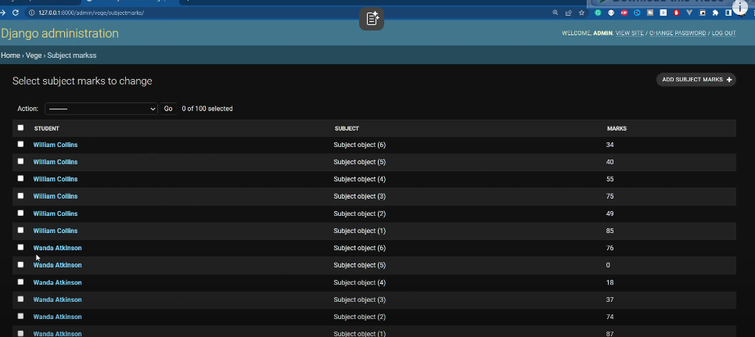

Or agr hum subject class may dander method call kry gy to subject k marks b a jaye gy

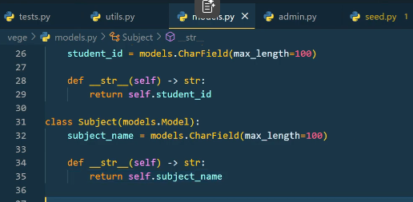

Def wala dunder method h

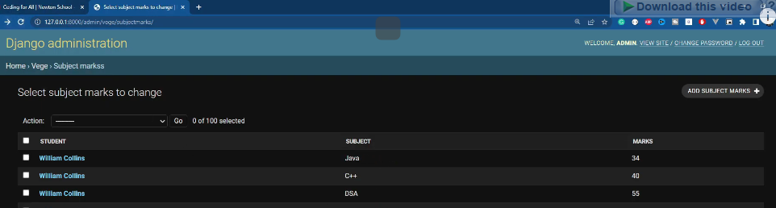

Assy phr marks name aye ga .

**18. Django Report card Project | Django Tutorial**

Hum is video may database means backend sy data frontend may lany waly hai.report card bnany k lie .or phr hum is may pagination and search b dekhy gy.ku k hum sara data ek sath ni bejh skty

Ab views may ja kr function bnaye gy

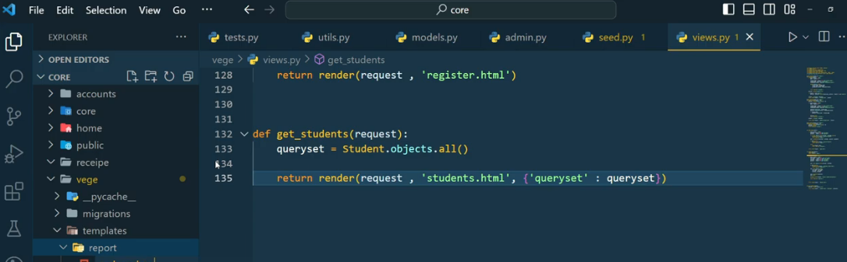

Phr ek html form banana h

Html route hota h us k bad iska url urls.py may define krna h 5.5SEC